Municipal Selection Criteria

Successful Municipal Criteria to Respond to Climate Change Challenges

I. BACKGROUND

MINARET “The MENA Region Initiative as a model of the NEXUS Approach and Renewable Energy Technologies”, is launching its phase II under “Empowering Municipal Governance for Climate Resilience Using WEF Nexus Approach” with the support of GIZ and through a close collaboration with Nexus Regional Dialogues Programme (NRDP) MENA. The project will be implemented at municipal level by the Royal Scientific Society – Amman and will be targeting Jordan, Egypt and Tunisia. The Project is the first of its kind in the region that utilizes a nexus approach to address the unique sustainability challenges and opportunities that face each of the countries from a local municipal level with regards to water, energy and food security. The Project facilitates dialogue between the experts and players from the public and private sector in renewable energy, sustainable development, water, climate change, and many more sectors. Stakeholders from all around the region discuss and plan together how to overcome the increasing constraints their countries and the region faces through fundamentally rethinking how we produce and consume energy in relation to the water and food sectors.

MINARET II aims to improve people’s lives by helping municipal governments to secure the funds and develop the skills they need to deliver high-quality public services, in particular with regard to natural resources management. It is structured of three components, which of the first component is Climate resilient municipalities: Membership in Covenant of Mayors – Strengthening municipal capacities to plan and manage climate change adaptation and mitigation measures (development of SECAP)

On an international scale, the Project is drawing the attention of experts, stakeholders and decision makers, this is because it tackles many of the world’s priority challenges and initiatives such as the Sustainable Energy and Climate Action Plan (SECAP) under the Framework of the EU- Covenant of Mayors (CoM). The project also addresses five of the UN Sustainable Development Goals: SDG 5- Gender equality, SDG 6- Water, SDG 7- Affordable and clean energy, SDG 11-Sustainable cities and communities, and SDG 13- Climate action. It is also because the Project utilizes the latest and most relevant framework of action worldwide. That is: the renewable energy, energy efficiency, water management and efficiency, and food security sectors are interlinked. Therefore, we must leverage existing synergies, bridge the gap, and bring together key stakeholders from across those sectors to achieve simultaneous gains in all those sectors at once.

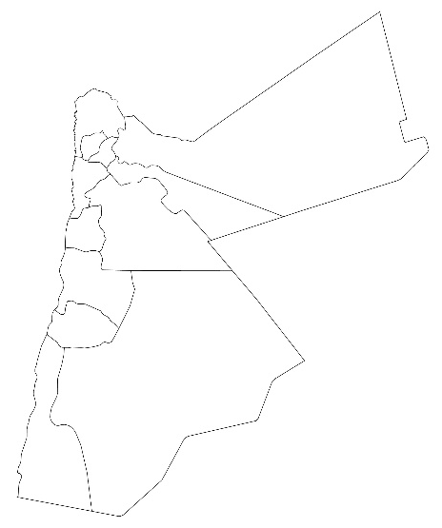
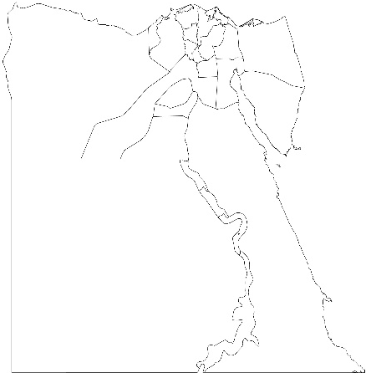

II. PURPOSE:

The Covenant of Mayors for Climate and Energy is offering cities, regions and provinces in the world countries the opportunity to enhance cooperation and support from national and subnational authorities, high international recognition and visibility for the local authority’s climate and energy action, and flexible reference framework for action, adaptable to local needs. Participation in the Covenant of Mayors for Climate & Energy supports the municipalities by providing them the recognition, resources and networking opportunities necessary to take their energy and climate commitments to the next level. This aims to increase local & regional authorities’ capacity and knowledge to mitigate and adapt to climate change.

The purpose of this activity is to select pilot municipalities which shall serve as a model that can be applied in other municipalities within the targeted countries. This step is essential to ensure that municipality staff is sufficiently motivated and that the municipality itself is visible and ready to be a role model for other municipalities joining the Covenant of Mayors.

III SELECTION CRITERIA

The selection of the municipalities is important for the success of the registration at Covenant of Mayor and for the implementation of Sustainable Energy and Climate Action Plan. The criteria for selecting the municipality are developed to ensure higher level of readiness and the expected better impact of implementing the climate projects in its area. Based on the objectives mentioned above, the criteria for evaluating the municipalities is broken down as described below:

A) Consistency with Country’s Economic and Social Priorities
This factor is neutralized due to the fact that the social and economic effects are similar for all municipalities. However, this factor will be taken into consideration when selecting the pilot municipality in rural/vulnerable areas.

B) Impact of Municipality

- Socio-economic and institutional context (e.g. population size, resources)
- Nature of climate hazards faced
- Stage of mitigation and adaptation work (e.g. implementation, design phase)
- Interests in sectors/areas of intervention
- Leadership and accountability
- Preparedness and forward thinking
- Coordination with NGOs/CSOs for implementing services within municipalities
- Communication and planning
- Readiness (municipal capacity in terms of staffing skills, structure IT capacity, quality concern, etc).
- Clearness of processes: in terms of existing documentation for the current processes in conjunction with the staff awareness and implementation of the documented processes.

IV ASSESSMENT OF NOMINATED MUNICIPALITIES

The assessment will be based on multi-dimensional surveys with vulnerable municipalities in Jordan, Egypt and Tunisia, that highlight municipalities ‘needs, and abilities. In addition to these survey tools, focus group discussions will be conducted with the management of the shortlisted municipalities: mayors, vice-mayors and municipal staff to learn about previous and current efforts to build municipal abilities through understanding the type of support they receive (capacity building, material support, etc.); who provides support (national, international or multilateral actors); what projects were developed or implemented; funding mechanisms; existing social capital, and emergency preparedness.

Municipality Survey:

Basic information

Name of authority *

Structure *

Municipality

District Municipality

Number of inhabitants of municipality *

Country *

Are you a Covenant of Mayors signatory? *

Yes, I am a signatory of the Covenant of Mayors 2030 targets

Yes, I am a signatory of the Covenant of Mayors 2020 targets and/or Mayors Adapt

No, I am not a signatory

Context - Mitigation
At what stage would you place your city in the mitigation work cycle? *

Preparatory phase: not started or getting started

Started designing our plan/strategy

Implementing our plan

Have already monitored and/or reported on achievements

What are your mitigation plan's objectives? (no more than 100 words) *
Ex: reduction of CO2 emissions by 40% by 2030 (if no objectives are planned, please write "NONE")

Has your municipality implemented any mitigation action in the following sectors? *

No Yes No, but I plan to do so
Municipal buildings, equipment,
facilities
Residential buildings
Energy
Waste management
Public transport
Private and commercial transport
Municipal fleet
Agriculture, forestry, fisheries

Context – adaptation
15. 16. How relevant are those climate hazards for your municipality? *

Not relevant Low Moderate Highs
Extreme heat/cold
Extreme precipitation/storm
Water scarcity
Flooding
Sea level rise
Drought
Landslides
Forest fires

At what stage would you place your city in the adaptation work cycle? *

Preparatory phase: not started or getting started

Started designing our plan/strategy

Implementing our plan/strategy

Have already monitored and/or reported on achievements

Has your municipality implemented any adaptation action in the following sectors? *

No Yes No, but I plan to do so
Buildings
Transport
Energy
Water
Waste management
Land use planning
Environment and biodiversity
Health
Agriculture, forestry, fisheries
Civil protection and emergency
Tourism

What are your adaptation plan's objectives? (no more than 100 words) *
Ex: reduction of CO2 emissions by 40% by 2030 (if no objectives are planned, please write "NONE")

